Reflection for Monday,
February 5, 2024

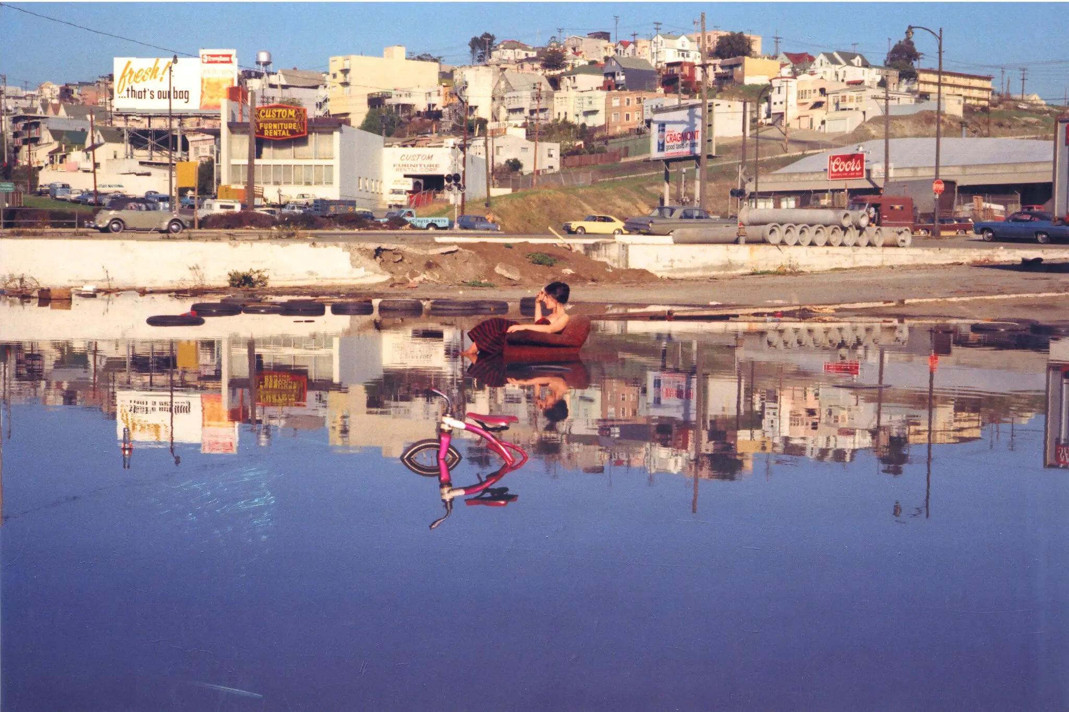

I was glad to see all of those who braved the atmospheric river and the winds to come to church yesterday. As we see more and more extreme weather, we need to stay attuned to the ways our environment is changing and what we can do to respond proactively to support all the living systems of the planet.

Thanks to Nancy Thursby, our Creation Justice Chair, for looking ahead into the year with a series of possible topics for further study and action. We ask that you let her know which issues you would like to focus on in the coming months. (Her contact information is at the end of the survey.)

For those who want to go on an excursion to see the Bonnie Ora Sherk exhibit I mentioned, here is a link with information to the Fort Mason Center with information: https://fortmason.org/event/bonnie-ora-sherk/
(I referenced the photo above of Ora Sherk’s “performance,” wading out into a flooded and junky area to sit in a ballgown on a discarded easy chair.” I celebrate Ora Sherk’s ability to see something fresh and new in environments that others see as entirely used up. So to return to my sermon theme of beginnings, I’ll share, once again, Mother Teresa’s reflection:

When you have nothing left but God, you have more than enough to start over again.

In faith,
Elizabeth

ORINDA COMMUNITY CHURCH
Creation Justice Survey
Nancy Thursby, Creation Justice Chair

Hi there, members and friends of OCC! Each year, I try to inform you as best I can about creation justice issues so that we can act upon them. I can’t cover all the possible topics, so it occurred to me that I should ask you what you are interested in having me emphasize during 2024.

Below are several creation justice topics upon which we could focus this year. Please indicate your interest preferences by indicating your first and second choice topics below. Or, if one in which you are interested is not listed, please write it in under “Other.” Thank you for participating!

Indicate your #1 and your #2 interest topic:

____ Clean air. This choice would continue our concern with the “Just Transition” of the fossil fuel industry to alternate energy sources and the protection of neighboring communities from unhealthy air.

_____ Clean water. This choice would be to renew our involvement with “Restore the Delta,” which is an organization that is working to preserve and renew the ecology of the Sacramento River delta. Another area of concern under water is rapid sea rise, which will effect communities around the bay and elsewhere.

_____ Ecological Food Production and Distribution. For many years, we have participated in Interfaith Power and Light’s Climate Action Week for Earth Day. This year, from an email I received: “The theme of 2024’s Faith Climate Action Week is “Common Ground: Cultivating Connections Between Our Faith, Our Food, and the Climate” We’ll examine how our food systems contribute to injustice and to climate change, and how our faiths call us to respond through practical solutions.” This choice is to participate in this again this year and work on this theme throughout the year.

_____ Plastic Pollution. From the Plastics Pollution Coalition: “Plastic pollution is an environmental, wildlife, climate, human health, and social justice issue. People and communities across the world are finally waking up to the fact that plastic pollution impacts everything.”

_____ Alternative Energy Sources. This choice would include advocating for laws that help the solar and wind industries and advocating for electric vehicles and charging stations. We have supported state legislation in favor of these efforts and had a successful electric vehicle show last fall.

_____ The Rights of Nature. From the Global Alliance for the Rights of Nature: The Rights of Nature “is the recognition that our ecosystems – including trees, oceans, animals, mountains – have rights just as human beings have rights. Rights of Nature is about balancing what is good for human beings against what is good for other species, what is good for the planet as a world. It is the holistic recognition that all life, all ecosystems on our planet are deeply intertwined.” There is a book and a movie on this idea.

_____ Other:

Hard copies will be available in church beginning February 4rd. If you are at home, please email your response to Nancy Thursby at:
nlthursby@comcast.net

**

We still need help with food and servers for the Thursday, February 8 dinner at Hope Solutions! Can you lend a hand? Contact Karen Sanford at ksanford227@gmail.com

**
Elizabeth will be away for a writing conference from Wednesday through Saturday (if she avoids catching Covid from Randy). We are delighted that Kurt Sunderbruch will be preaching on Sunday, February 11, with able and creative accompaniment from Lee Cruise. We are so glad to have them!

Relatedly, there will be no in-person contemplative service on Wednesday, and Thursday’s Theology and Scripture and Reading Group meetings are cancelled. The next meeting of the Reading Group will be on February 15th at 3:30. Let Elizabeth know if you’d like a Zoom link for the group.

**

Lent is almost here. Please join us for a 10 a.m. Ash Wednesday service in the chapel on February 14th.
Valentine’s Day and Ash Wednesday on the same day? We will try to get creative.

