Contemplative Service for Wednesday,
March 13, 2024

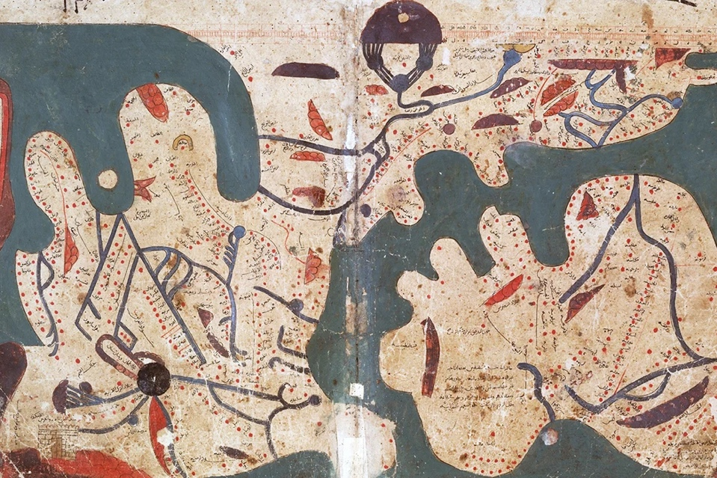
From The Book of Curiosities: a Medieval Islamic View of the Cosmos

First reading: from the Exodus Rabbah Midrash, (31:15), trans. H. Freedman and Maurice Simon
Observe how all things borrow from each other […] day borrows from night and night from day…the moon borrows from the stars and the stars borrow from the moon…the sky borrows from the earth and the earth from the sky…All God’s creatures borrow from the other, yet make peace with one another…

Music: Ubi Caritas, by Ola Gjeilo, performed by VOCES8
https://www.youtube.com/watch?v=B-50CeNelnA

Second reading: from Teresa of Avila

Just because the soul sits in perpetual peace does not mean that the faculties of sense and reason do, or the passions. There are always wars going on in the other dwellings of the soul. There is no lack of trials and exhaustion. But these battles rarely have power anymore to unseat the soul from her place of peace.

Music: Ubi Caritas, by Ola Gjeilo, performed by Zero8
https://www.youtube.com/watch?v=zckmFxwagOU

Time of Silent Contemplation

Dear Lord and Father of humankind,
Forgive our foolish ways;
Reclothe us in our rightful mind,
In purer lives Thy service find,
In deeper reverence, praise.
Drop Thy still dews of quietness,
Till all our strivings cease;
Take from our souls the strain and stress,
And let our ordered lives confess
The beauty of Thy peace.
Breathe through the heats of our desire
Thy coolness and Thy balm;
Let sense be dumb, let flesh retire;
Speak through the earthquake, wind, and fire,
O still, small voice of calm.
—John Greenleaf Whittier

Communal blessing
Loving Guide,
Lead us into peace, and may peace itself be our discernment.
We ask to learn to learn the difference between strife and striving, between intensity and intimacy.
May our emergences, held in care and in calm, reshape themselves into emergence.
May this be so.

Music: Ubi Caritas, by Ola Gjeilo, performed by Apollo 5
https://www.youtube.com/watch?v=3AGPLItbx0w

We are always peace.
To get rid of the idea that we are not peace
is all that is required.
— Ramana Maharishi

