Contemplative Service for Wednesday,
March 29, 2023

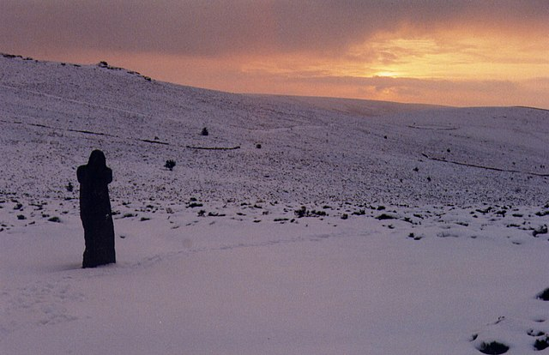

First reading: Matthew 10:39
The one who has found their life will lose it, and the one who has lost their life for My sake will find it.

Music: “Lost Song” by Olafur Arnalds
https://www.youtube.com/watch?v=zVVUJLQnflA

Second reading: from “Prophecy” by Dana Gioia

O Lord of indirection and ellipses,
ignore our prayers. Deliver us from distraction.
Slow our heartbeat to a cricket's call.

In the green torpor of the afternoon,
bless us with ennui and quietude.
And grant us only what we fear, so that

Underneath the murmur of the wasp
we hear the dry grass bending in the wind
and the spider's silken whisper from its web.

Music: “Song for the Seeker: by Avrial and the Sequoias
https://www.youtube.com/watch?v=p1j2cZg2McI

Time of Silent Contemplation:
My Lord God, I have no idea where I am going. I do not see the road ahead of me. I cannot know for certain where it will end. Nor do I really know myself, and the fact that I think that I am following your will does not mean that I am actually doing so. But I believe that the desire to please you does in fact please you. And I hope I have that desire in all that I am doing. I hope that I will never do anything apart from that desire. And I know that if I do this you will lead me by the right road, though I may know nothing about it. Therefore will I trust you always, though I may seem to be lost and in the shadow of death. I will not fear, for you are ever with me, and you will never leave me to face my perils alone.
—Thomas Merton

Communal Blessing:

Though we try so hard to lose you, there you are in our dreams, in our inappeasable passions and in our solace. Holy One, erase destination from our hearts. Holy Wandering, we follow you, but where? We are like a hair released from the scalp that floats away on invisible currents.

When there is no place left to go, when we are held still in our lostness, may we open to you. You are Holy Direction, Steadfast Compass. You are a map written into the palms of our hands which we open and lift to you. Pull us toward your center. Amen.

Music: “I Still Haven’t Found What I’m Looking For” by U2, performed by Sarah Jarosz
https://www.youtube.com/watch?v=OAcu5g8AMEs

Seeker, may you be found.
Peace to you.

