Contemplative Service for Wednesday
July 12, 2023

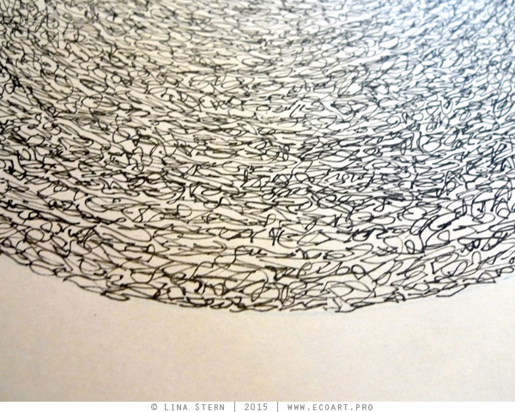

First reading: John 1:1-5

In the beginning was the Word, and the Word was with God, and the Word was God. This One was in the beginning with God. All things came into being through this One, without whom not one thing came into being. What has come into being thus was life, and the life was the light of all people. The light shines in the darkness, and the darkness did not overcome it.

Music: “Song Without Words, Op. 19 No. 1” by Felix Mendelssohn, performed by Mia Pečnik

https://www.youtube.com/watch?v=t6WRHTjnA-U

Second reading: C.S. Lewis, from Letters to Malcolm

Prayer without words is the best.

Music: “Song Without Words, Op. 109” by Felix Mendlssohn, performed by Yo-Yo Ma

https://www.youtube.com/watch?v=Bv0FwfG9ZuM

Time of Silent Contemplation

Prayer is not so much talking to or addressing God, but rather about deepening our awareness that God — the Breath of Life present throughout the universe — comes to visible expression in us.
—Michael Morwood

Communal Blessing
Word unspoken, but all-availing, we ask to be lifted on your unspoken syllables, crooned in your silent vowels. Word-Made-Flesh, here is the expression whose meaning we cannot control or fully understand. We enter the great and dynamic silence of your saying. We speak nothing but enter the Word of your freedom and wholeness. Amen.

Music: “Song Without Words Op 67 No 2,” by Felix Mendelssohn, performed by Yuja Wang
https://www.youtube.com/watch?v=ievpSwyvxoE

May the Word be with you, infuse you, and arise from within you.

