20+C+M+B+23

Contemplative Service for Wednesday, December 28, 2022

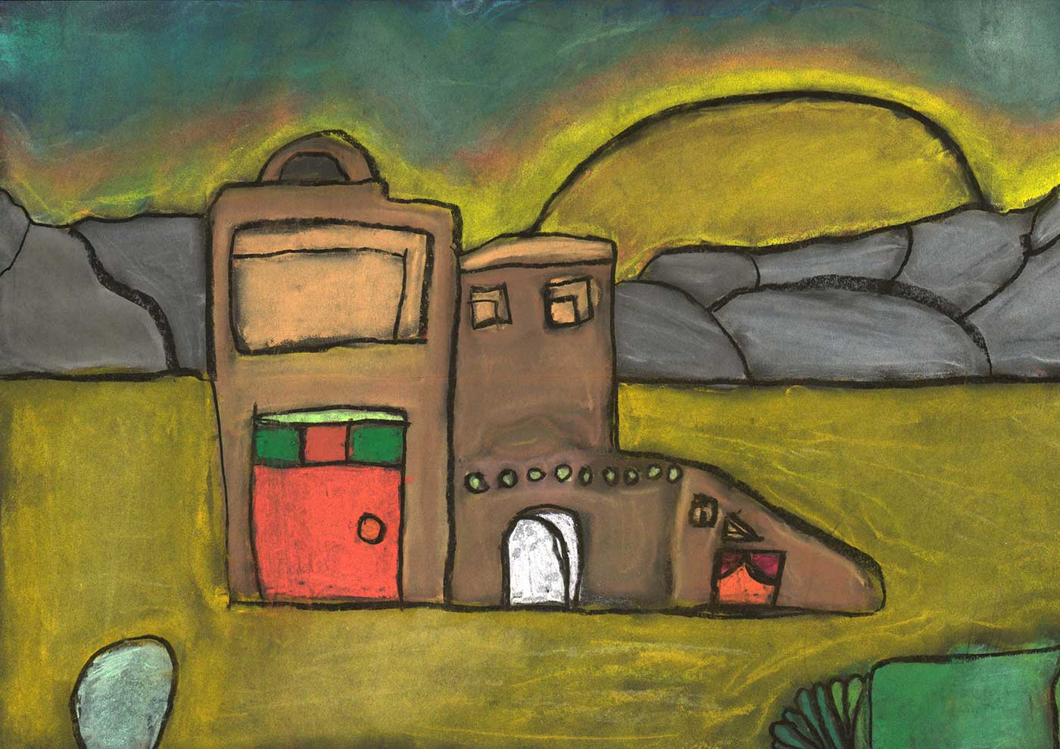

chalk drawing by Julie Immediato

For every house is built by someone, but God is the builder of everything.

First Reading: Isaiah 32:18

My people will live in peaceful dwelling places, in secure homes, in undisturbed places of rest.

Music: “I’m Going Home,” First Ireland Sacred Harp Convention
https://www.youtube.com/watch?v=t4liEuDm8ac

Second Reading: from a Catholic House Blessing at Epiphanytide
When Jesus took flesh through Mary, he made his home with us. Let us now pray that he will enter this home and bless it with his presence. May he always be here among us; may he nurture our love for each other, share in our joys, comfort us in our sorrows. Inspired by his teachings and example, let us seek to make our homes before all else a dwelling place of love, diffusing far and wide the goodness of Christ.

Music: “Coming Home” by Ocie Elliott
https://www.youtube.com/watch?v=2T4gnCCFj8I

Time of Silent Contemplation

Eternal Light and Creator of all lights,
bless this new fire.
Grant that after the darkness of this world,
we may come with pure hearts to Thee,
the never-failing Light, our Home. Amen

—from an ancient Catholic blessing of the hearth

Communal Blessing
Holy Haven,
Guide us into the new year, and make your presence a living habitation for us.
May there be doors and windows that let in light, air, and guests,
but which can also be closed to provide for safety, rest, and reflection.
You, our Home, know the color, texture, and beauty we need.
You are our architecture and our creature comforts.
Surround us, then, in what you are. Sanctuary. Love.

Music: “Home” by Edward Sharpe & the Magnetic Zeros
https://www.youtube.com/watch?v=DHEOF_rcND8

Now be pleased to bless the house of your servants, that it may continue forever in your sight; for you, Holy One, have spoken, and with your blessing our house will be blessed forever.

