Contemplative Service for Wednesday,
January 10, 2024

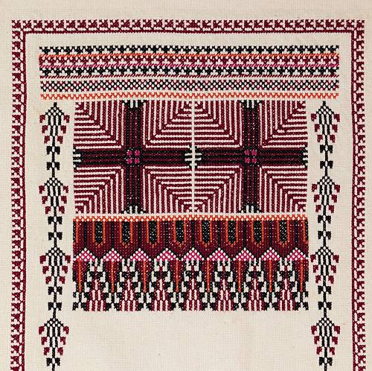
Embroidery by Tania Tamari Nasir

We are all one—and if we don't know it, we will learn it the hard way.
—Bayard Rustin

First reading: from Bayard Rustin

When an individual is protesting society's refusal to acknowledge his dignity as a human being, his very act of protest confers dignity on him.

Music: “Guide My Feet,” performed by First Presbyterian Church of Brooklyn
https://www.youtube.com/watch?v=z-WVIppNBls

Second reading: 1 Corinthians 6:17

But the one who is joined with the Divine becomes one spirit with Holy One.

Music: “Hold On” performed by Bobby McFerrin and the Kuumba Singers
https://music.youtube.com/watch?v=wWEB64ewzzc&list=RDAMVMwWEB64ewzzc

Time of Silent Contemplation

Now you will feel no rain, for each of you will be shelter for the other.
Now you will feel no cold, for each will be warmth to the other.
Now there will be no loneliness, for each will be companion to the other.
Now you are separate lives, but there are three lives before you:
one’s life, the other’s life, and your life together.
Go now to enter into your days together.
And may all your days be good and long upon the Earth.

—Apache Prayer

Communal Blessing

May the breaking of our hearts at human suffering be a breaking of our resistance to you.
Let us resist love no longer.
We pray that you will show us, God, who we really are,
and that there will be no sorrow or shame in what we learn
but the endless union and energy of your love. Amen.

Music: “I Want Jesus to Walk With Me,” performed by Marion Williams
https://music.youtube.com/watch?v=5TvF5dl9P0Q

May we all walk in unity and in peace.

