Contemplative Service for Wednesday,
December 13, 2023

Third Week of Advent: Joy

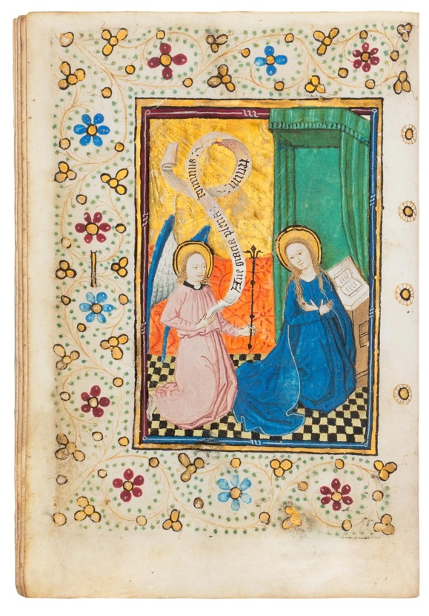
15th Century illuminated manuscript, Dutch

First reading: Psalm 94:19

When the cares of my heart are many, your consolations cheer my soul.

Music: Excerpt from Busoni’s “Nuit de Noelle” performed by Igor Levit
https://www.youtube.com/watch?v=sXjJquwsFh4

Second reading: from Soren Kierkegaard
It takes moral courage to grieve; it requires religious courage to rejoice.

Music: Partita No. 1 in B flat major—BWV 825 by Bach, performed by Igor Levit
https://www.youtube.com/watch?v=hg0EItS0cu0

Time of Silent Contemplation

May all I say and all I think
be in harmony with thee,
God within me,
God beyond me,
maker of the trees.
—Chinook prayer

Communal Blessing:

Sacred One,
We enter the Holy of Holies in awe and fear, but are opened to light, openness, and joy. How have we so misunderstood you, God? Your deepest haven is not dark, but alive with freedom. We stretch, we move, we breathe into you. We embrace joy as nourishment and as necessary oxygen. We live our joy in defiance of the world we have always known as broken. Here is your world, made of kindness and joy. We step into it. Amen.

Music: “Ode to Joy,” from Beethoven’s 9th Symphony, performed by Igor Levit
https://www.youtube.com/watch?v=t1f_cDQDEYY

May peace and wholeness arrive for you in the form of joy.

