Contemplative Service for Wednesday,
March 15, 2023

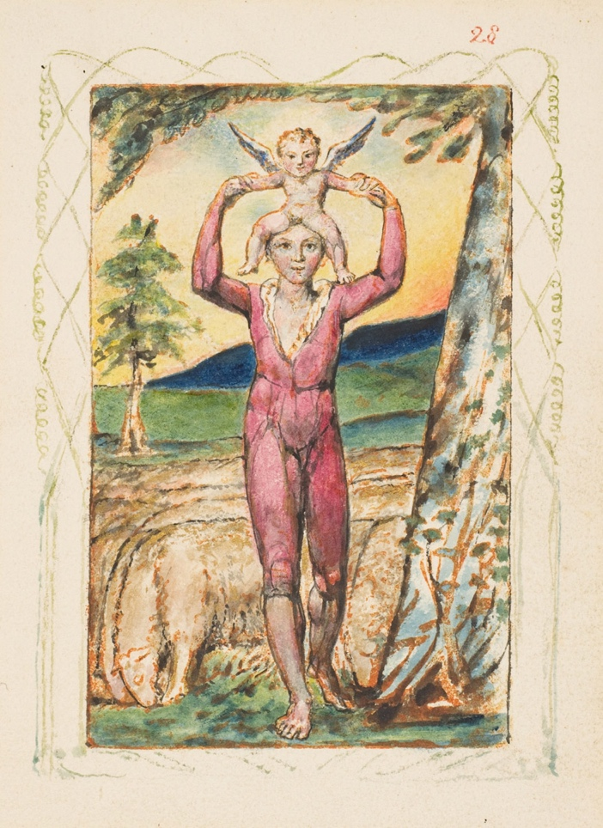

art by William Blake, from “Songs of Innocence and Experience”

First reading: from Proverbs 4: 1-6, 22-23
Hear, O children, my instruction, and be attentive, that you may gain insight, for I give you good precepts; do not forsake my teaching.
When I was a little one with my father,
tender, the only one in the sight of my mother,
they each taught me and said to me,
“Let your heart hold fast my words.
Get wisdom; seek insight;
Do not forsake wisdom, and she will keep you;
love her, and she will guard you.”

For these teachings are life to those who find them,
and healing to all their flesh.
Keep your heart with all vigilance,
for from it flows the springs of life.

Music: Taize, “In Our Darkness, There is No Darkness”
https://www.youtube.com/watch?v=Y4FM0dbV9ng

Second reading: from “Litany for Becoming” by M. Jade Kaiser, “Enfleshed”
To become is a life long process.
Nothing is constant,
not even the self.
We evolve in the midst of narratives meant only for some
and ways of being made narrow by fear and power.
We must, then, have the courage to listen to the truth of our own lives,
to the wisdom that comes from within –
responding without resistance or need to control,
but with welcome and curiosity.
This is what ensures our becoming is an unfolding
of our truest self.
This lifelong labor cannot be carried out alone. It requires help
from friends, and lovers, family, and creaturely companions
who bear witness to what makes us come alive.
And say to us, “Listen. Look. Feel. Pay attention to that.”
This is loving and being loved.

Music: Taize, “Within Our Darkest Night”
https://www.youtube.com/watch?v=J8BmvxqJH0g

Time of Silent Contemplation

O great and holy God, I pray thee,
set open my inwardness to me;
that I may rightly know what I am;
and open in me what was shut up in Adam.
—Jacob Boehme

Communal Blessing

Loving Creator, we ask that you carve a hollow in our experience
and then pour into it your wisdom.
Pour and pour yourself, God,
into our aching hollowness until we overflow.
Until we overflow and our surfaces are glazed with your shining wisdom.
We are fragile vessels, but as we absorb your living essence,
our brittleness gives way.
We are clay crumbling into the soil.
There we are united with you, water, soil, seed.
United with all that has been sown, has been grown, all that is yet to be. Amen.

Music: Taize, “My Soul is at Rest”
https://www.google.com/search?client=firefox-b-1-d&q=taize%2C+my+soul+is+at+rest#fpstate=ive&vld=cid:4f38b718,vid:yHfp4qzdfQY

May you move through the coldest days into the warmth of wisdom.

