Ash Wednesday
February 22, 2023
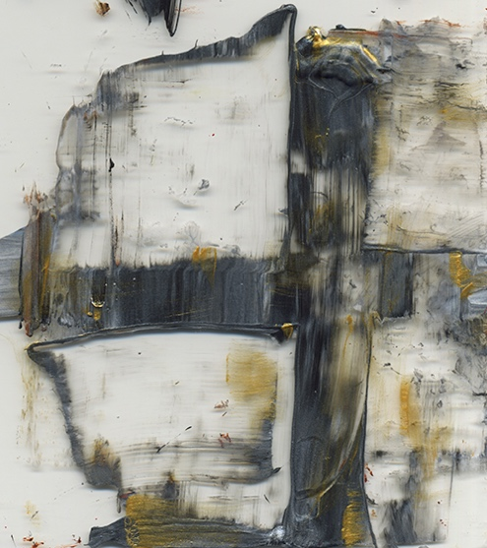
image by Jan Richardson

Reflection: The authorities say that God is a being, an intelligent being who knows everything. But I say that God is neither a being nor intelligent and He doesn’t ‘know’ either this or that. God is free of everything and therefore He is everything.

If I had a God I could understand, I would no longer consider him God.
–Meister Eckhard

First reading: adapted from John 3: 16-17
God so loved the world that God sent Jesus, Divine Child,
so that everyone who believes and follows will not be left behind, but live in the great journey of faith. God did not send Jesus into the world to condemn the world,
but in order that the world might be renewed through his life.
Music: “My Song is Love Unknown,” performed by Emu Music
https://www.youtube.com/watch?v=7CPlrA1CMwo

Second reading, adapted from Julian of Norwich
God, you have willed that in all things we humans have Love as our central recognition and our central joy. Yet we remain blind to this recognition and joy so often. For some of us believe that God is Almighty and may do all things, and that God is All-Wisdom and can know all. But that
God is All-Love and will do all? There we stop short. And this not-knowing—this is what most hinders us most as lovers of God. Therefore we pray to pause in our ways and enter into a deeper knowing, a more profound loving, of self and of others, and of you, oh Holy Love. Amen.

Music: “O pastor animarum” by Hildegard of Bingen

https://www.youtube.com/watch?v=taanHO13WXE

Scripture Reading
Luke 4: 1-13
Jesus, full of the Holy Spirit, left the Jordan and was led by the Spirit into the wilderness, where for forty days he was tempted by the devil. He ate nothing during those days, and at the end of them he was hungry. The devil said to him, “If you are the Son of God, tell this stone to become bread.” Jesus answered, “It is written: ‘Man shall not live on bread alone.’” The devil led him up to a high place and showed him in an instant all the kingdoms of the world. And he said to him, “I will give you all their authority and splendor; it has been given to me, and I can give it to anyone I want to. f you worship me, it will all be yours.” Jesus answered, “It is written: ‘Worship the Lord your God and serve him only.’” The devil led him to Jerusalem and had him stand on the highest point of the temple. “If you are the Son of God,” he said, “throw yourself down from here. For it is written: “‘He will command his angels concerning you to guard you carefully; they will lift you up in their hands, so that you will not strike your foot against a stone.’” Jesus answered, “It is said: ‘Do not put the Lord your God to the test.’” When the devil had finished all this tempting, he left him until an opportune time.
Prayer for the Imposition of Ashes
We accept these ashes and our very human mortality
as a blessing given by the Divine, and not as a mark of humiliation.
For we turn to you, Loving One, turn to your life,
and so turn to the journey ahead of us. Blessed be.

Closing Prayer, A Prayer for Wanderers from Queer Theology
God of the seekers and dreamers, the disaffected and disillusioned, the worn out and burnt out, the rejected and leavers…
We ask for blessings as we travel, as we doubt, as we meander.
We ask for the grace to leave when necessary, to come home when we can, to create new homes when we need to.
We ask for protection of our souls from those who don’t understand, who judge, who mock. We ask for the fortitude to undertake the journey even when it’s scary (or, maybe, especially when it’s scary).
We know that as we wander we are not alone and as Tolkien says that “Not all who wander are lost.” We know that sometimes we have to leave the confines of what we knew to see the truth, to hear Your voice, to find out what to do next.
We pray you lead us where we need to go, by whatever route it takes. We pray for new ways to see You, to understand new ways of being in the world. We pray for healing and for redemption, and, where possible, reconciliation.
We pray for all of this so we can know wholeness, know our bodies, know each other, know You. And be found. Amen.

Music: “Unknowing Abide” written and performed by Darlene Franz
https://wisdomchant.bandcamp.com/track/unknowing-abide

Charge and Blessing from Marguerite of Porete
May you have no shame, no honor, no fear for what is to come. You are secure, says Love. Your doors are open. Journey forth. No one can harm you.

