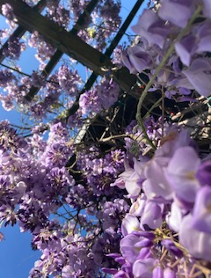
Reflection for April 22, 2024

Jay-blue heavens, flooding o’er
Rain- soaked beams latticing through
Pink Purple Globes, wafting down
Soft lacy petals, kissing
Upturned brow, lids, lips, stirring
Warmth into old, wriggling toes!

—Katrina Staten

I’m sharing Katrina’s lovely poem once again so that you can have the pleasure of seeing it accompanied by her photograph. I love the sense of the natural world coming down to kiss her! As I get ready to go on my sabbatical, my hope is for all of you to have a season of sun-kissed pleasures and happy adventures.

I am so grateful to the Lilly Foundation for the clergy renewal grant they have given to me—and to us as a congregation. The theme of my sabbatical proposal is “discovering what sabbath is,” and I admit that I’m not really skilled at the sabbath thing. To me, the purpose of life has been to say “yes, yes, yes” to every possibility. But a person can only sustain that for so long. So my experiment for the next three months will be to slow down and do less, less, less.

This week I’ll be at the church as usual, but with Rev. Lindsay Fulmer, our sabbatical interim pastor. This will permit us to do a thoughtful orientation (and for me to remember all the details I haven’t yet shared with her about our weekly activities).
If you aren’t going to see Victoria Rue’s terrific films at Rossmoor on Friday evening, I’d be delighted to see you in the chapel at 7:30 on Friday night where I’ll be reading poems Susanne Dyckman, the collaborator on my new book, and Chris Daniels who has recently published translations of poems by Orides Fontela. My son Jonah will be showing some of his artwork as well.

So, while I will probably see many of you this week and next Sunday, I’d like to take a moment to say how much I will miss you while I am gone. You will all be in my heart, and I thank you for your incredible commitment and generosity—to me, to this church community, and to God.

Blessings to all of you.

In faith,
Elizabeth

