Reflection for Monday, November 20, 2023

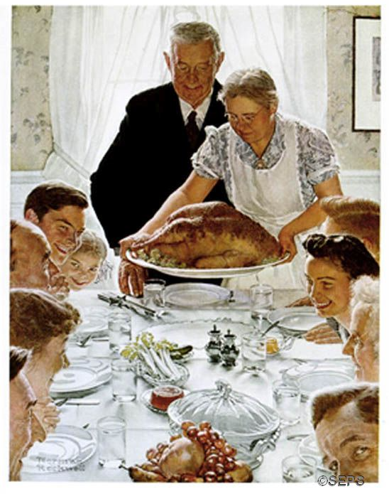
Norman Rockwell’s “Freedom from Want”

When I was a kid and my family was returning from a vacation or trip, as we arrived home, my mother would always say, “Home again, home again, jiggity jig.” Another friend recently told me that her mother would say the same thing. And then, during a visit this summer, as I pulled into the driveway, my mother again said, “Home again, home again, jiggity jig,” commenting, “You know, my mother would always say that when we were returning from a trip.”

Randomly, I looked this up and immediately found a radio show about idioms in which a woman said her mother used to do the same thing! It seems that the phrase is over two hundred years old and was a farmer’s going-to-market song:
To market, to market to buy a fat pig,
Home again, home again, jiggety jig.

That “jiggety jig” is thought to be the sound of the wheels on the cart turning. There are many additional verses, but, really, what strikes me is that this strange tradition seems pretty pervasive!

During this Thanksgiving week, there will be many departures and arrivals. Randy and I will be coming home from our vacation and getting back to work, but we will pause on Thursday for a new tradition: my son Wilson has invited us to join him and his fiancée and his co-workers at the fire station where he is working. We will share a meal, and hope it won’t be interrupted by any fires or emergencies.

So wherever you are this week, travel safely. I hope you are with people you love and who love you. I hope you eat delicious food. I hope you are able to relax into pleasure and gratitude. Most of all, I hope you find yourselves home again, home again wherever you are.

In faith,
Elizabeth

Announcements:

A great big thanks to Kurt Sunderbruch for preaching for the last two Sundays!

Regular programs and events at the church will occur as usual this week except on Thursday and Friday when the church office will be closed. However, if you have any needs, feel free to contact Elizabeth.

