Reflection for Monday,
January 22, 2023

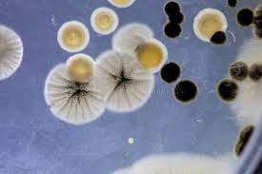

Yesterday, Randy and I went to our storage unit to find one of the treasures that is undoubtedly buried there. What we found instead was that our storage unit had flooded during the rain storms.

Cleaning it up, I had an opportunity to reflect on the nature of mold. There’s your powdery mold, and your slimy mold. There’s green mold and black mold, and mold that makes orangey-red streaks on fabric. It appears that any mold you encounter is going to smell bad.

OF COURSE I came up and did a little science study. So here’s a refresher for those of you who haven’t had occasion to reflect on mold recently. Mold is a kind of fungus. It doesn’t grow from seeds but from tiny spores that float in the air. When the spores come in contact with a piece of damp food or other material, they feast on it and grow. It may seem disgusting, but in a positive way, molds accelerate the process of rotting which makes mold a natural recycler.

Thinking about all this caused me to remember the parable in Matthew that proclaims that the kingdom of God is like yeast that a woman worked into dough for her bread, causing it to rise.

So why shouldn’t the kingdom of God be like mold that floats in the air and breaks down things we no longer need? (Well, sometimes it breaks down things we do want to keep, but we can mostly avoid that.) Maybe this is a farfetched idea, but I like the possibility that God wastes nothing, and that when a thing—an object or even an idea or an emotion—have come to the end of their useful life, God will send a little spore to land on it, break it down, and recycle it into something new.

Mostly, I have a sense that God is in everything: God, active in reclaiming what we believe to have been lost, teaches us about eternal life in the most unexpected of ways, even through mold.

In faith,
Elizabeth

