Reflection for Monday, April 1, 2024

Easter Blessing

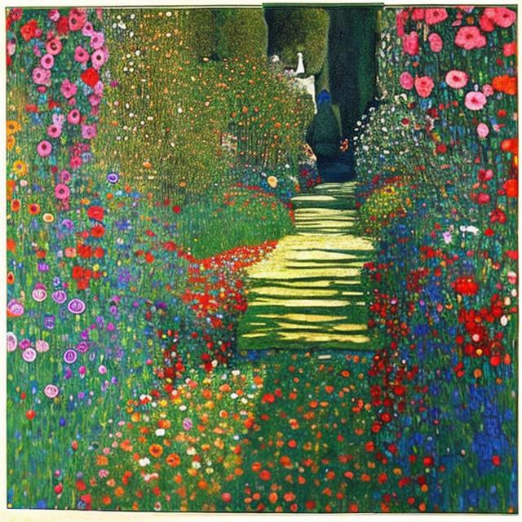
Painting by Gustav Klimt

May your grief and your losses find new language as wisdom.
May your fears lose their grip and become awareness of your limits.
May your confusion and frustration release into the energy of courage.
May wonder be the resource of your every day.
May life itself be sufficient to give you ready evidence of joy.
May you know yourself, and know yourself as made of God’s love.

For God is love.
God is the course of resurrection.
We bless our lives though we understand that earthly life
is broken by wounds and can dry up and fly away like ash.
We want to deny that life contains evil, but then we are overwhelmed by it
and we sometimes taste it in our own mouths.

In that fragmentation and despair,
we are visited by the human warmth of God in the person of Jesus
who holds our faces in God’s kind hands,
whose arms lift and warm us.
When we cannot bless our own lives with love,
Jesus blesses them for us.

For God is love and the way of resurrection.
And Jesus’s word is with God and is God.
Jesus’s word is your name and mine,
a name for every person and creature,
a name for every living thing and all life,
a word that overturns death with love.

No longer alone, no longer ill,
no longer distracted or weakened.
We live supple and strong in the love
that made resurrection and made us.

We arise to the call of that love.
We can no longer resist the wholeness that was made for us.
Complete. Radiant. Beloved. Alive.

This Easter blessing is for you.

Announcements

We are eager to hear Karen Sanford share her spiritual journey! Please join us next Sunday, April 7, after church when we will hear from Karen about her life.

*

Thank you to all who contributed to our offering for the Black Wealth Builders Fund. It is not too late to contribute! We encourage you to participate in this important fund. You can write checks to O.C.C. with “Black Wealth Builders” in the memo.

