Reflection for Monday,
July 31, 2023

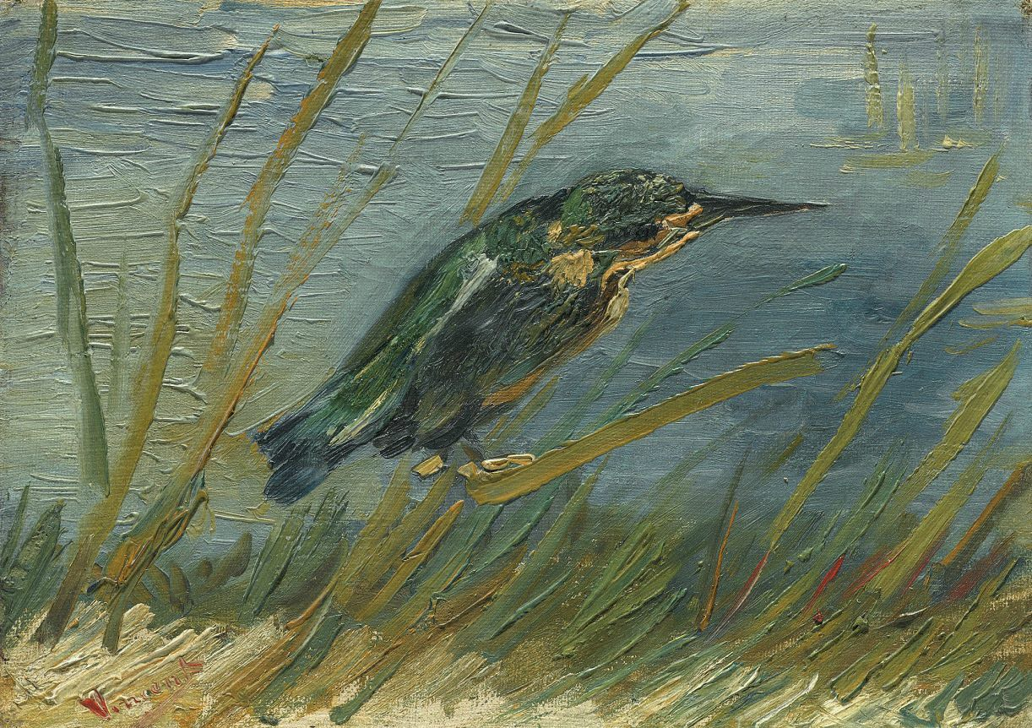
detail from a painting by Vincent Van Gogh

We are on the cusp of a new month, and I’m hoping that August will be temperate in weather and in spirits.

I have found life rough going for the past several months, and if you are feeling similarly, my sympathies are with you.

I have a number of strategies I employ when I’m going through a challenging time—to try to find conscious pleasure in something every day, to offer up gratitude, to look around me to all the people I love, and to break down big projects into doable increments. Exercise helps too.

But lately I have also found myself thinking back to Bible verses I memorized (sometimes under duress) as a child, and this is what arose in memory:

Draw near to God, and God will draw near to you.

(I looked it up and it is from James 4:8.).

This sums it up for me. I’ve been lucky to hear from many of you about your encounters with God, spirit, the holy (however you name it) and I know that we have, together, a vast bank of experience that tells us of God’s presence. I hope we can continue to share that in conversation and justice work and in celebration and play.

Sometimes I’m not sure how to draw near to God, but we can practice together, and together we can witness to how God responds and draws near to us.

In faith,
Elizabeth

Announcements

Many thanks to Lee Cruise for preaching this weekend when Elizabeth was called away.

*

Hope Solutions is still in need of backpacks for students!

